Association, Composition and Aggregation in Java
import java.io.*;
import java.util.*;
class Bank {
private String bankName;
private Set<Employee> employees;
public Bank(String bankName)
{
this.bankName = bankName;
}
public String getBankName()
{
return this.bankName;
}
public void setEmployees(Set<Employee> employees)
{
this.employees = employees;
}
public Set<Employee> getEmployees()
{
return this.employees;
}
}

// Class 2
class Employee {
private String name;
// Constructor of Employee class
public Employee(String name)
{
this.name = name;
}
public String getEmployeeName()
{
return this.name;
}
}

// Class 3
class AssociationExample {
// Main driver method
public static void main(String[] args)
{
// Creating Employee objects
Employee emp1 = new Employee("Ridhi");
Employee emp2 = new Employee("Vijay");
// adding the employees to a set
Set<Employee> employees = new HashSet<>();
employees.add(emp1);
employees.add(emp2);
// Creating a Bank object
Bank bank = new Bank("ICICI");
// setting the employees for the Bank object
bank.setEmployees(employees);
// traversing and displaying the bank employees
for (Employee emp : bank.getEmployees()) {
System.out.println(emp.getEmployeeName()
+ " belongs to bank "
+ bank.getBankName());
}
}
}
OUTPUT
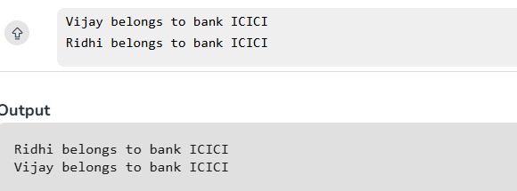

Design Browser History
import java.util.*;
class BrowserHistory {
ArrayList<String> history;
int current;
public BrowserHistory(String homepage) {
history = new ArrayList<>();
history.add(homepage);
current = 0;
}
public void visit(String url) {
while (history.size() > current + 1) {
history.remove(history.size() - 1);
}
history.add(url);
current++;
}
public String back(int steps) {
current = Math.max(0, current - steps);
return history.get(current);
}
public String forward(int steps) {
current = Math.min(history.size() - 1, current + steps);
return history.get(current);
}
}
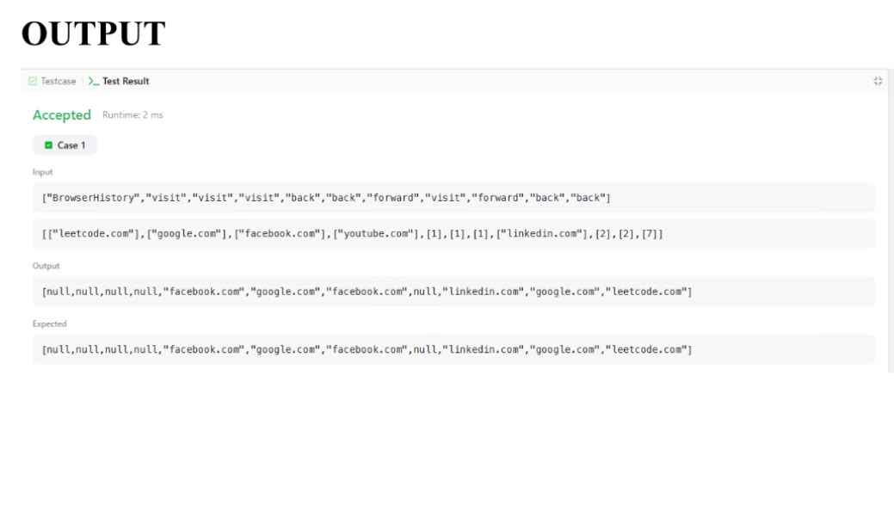

Design HashSet
class MyHashSet {
boolean[] set;
public MyHashSet() {
set = new boolean[1000001];
}
public void add(int key) {
set[key] = true;
}
public void remove(int key) {
set[key] = false;
}
public boolean contains(int key) {
return set[key];
}
}
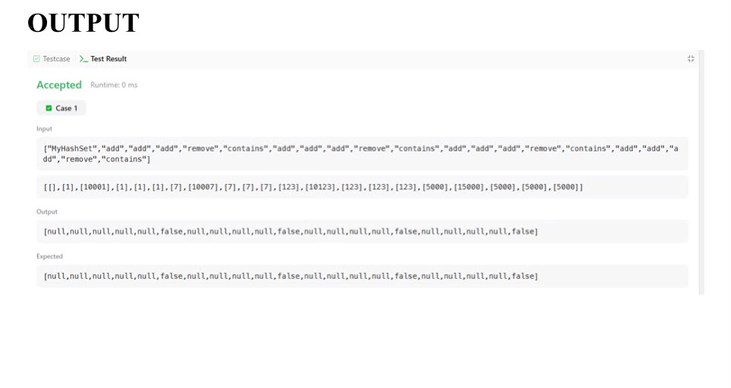

Design Parking System
class ParkingSystem {
int big;
int medium;
int small;

public ParkingSystem(int big, int medium, int small) {
this.big = big;
this.medium = medium;
this.small = small;
}

public boolean addCar(int carType) {

if (carType == 1) {
if (big > 0) {
big--;
return true;
}
}

else if (carType == 2) {
if (medium > 0) {
medium--;
return true;
}
}

else if (carType == 3) {
if (small > 0) {
small--;
return true;
}
}

return false;
}
}
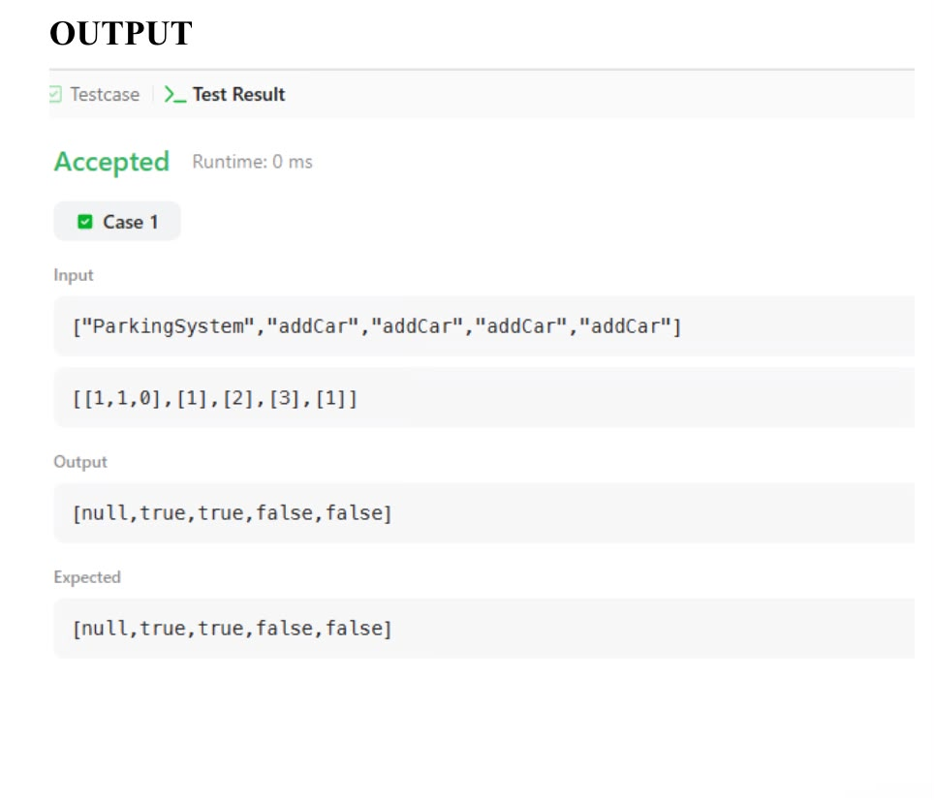

Design Underground System
import java.util.*;
class UndergroundSystem {
Map<Integer, CheckIn> checkIns;
Map<String, int[]> trips;
public UndergroundSystem() {
checkIns = new HashMap<>();
trips = new HashMap<>();
}
public void checkIn(int id, String stationName, int t) {
checkIns.put(id, new CheckIn(stationName, t));
}
public void checkOut(int id, String stationName, int t) {
CheckIn checkIn = checkIns.get(id);
String route = checkIn.station + "->" + stationName;
int travelTime = t - checkIn.time;
if (!trips.containsKey(route)) {
trips.put(route, new int[]{0, 0});
}
trips.get(route)[0] += travelTime;
trips.get(route)[1]++;
checkIns.remove(id);
}
public double getAverageTime(String startStation, String endStation) {
String route = startStation + "->" + endStation;
int[] data = trips.get(route);
return (double) data[0] / data[1];
}
class CheckIn {
String station;
int time;
CheckIn(String station, int time) {
this.station = station;
this.time = time;
}
}
}
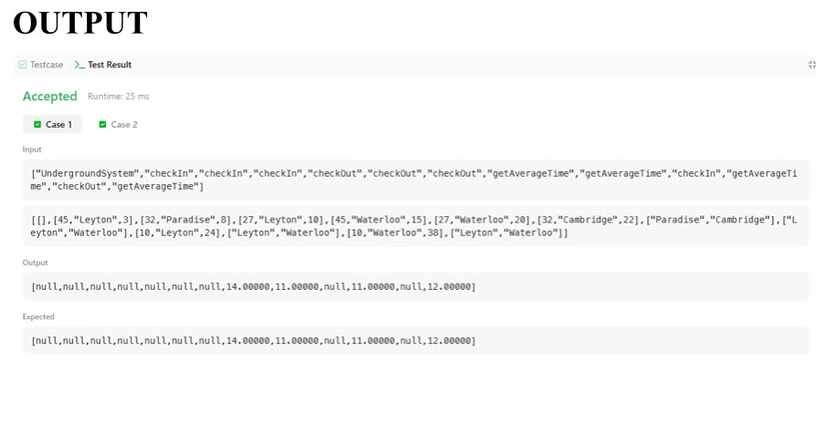

Generics in Java
class Test<T> {
T obj;
Test(T obj) {
this.obj = obj;
}
public T getObject() { return this.obj; }
}
class Geeks {
public static void main(String[] args)
{
// instance of Integer type
Test<Integer> iObj = new Test<Integer>(15);
System.out.println(iObj.getObject());
// instance of String type
Test<String> sObj
= new Test<String>("GeeksForGeeks");
System.out.println(sObj.getObject());
}
}
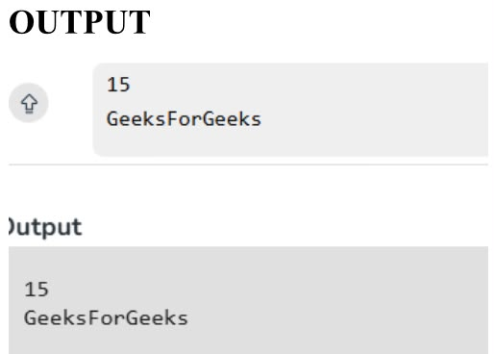
Grading Students
import java.io.*;
import java.util.*;
class Result {
public static List<Integer> gradingStudents(List<Integer> grades) {
List<Integer> result = new ArrayList<>();
for (int grade : grades) {
// Grades below 38 are not rounded
if (grade < 38) {
result.add(grade);
}
else {
// Find next multiple of 5
int nextMultiple = ((grade / 5) + 1) * 5;
// Round if difference is less than 3
if (nextMultiple - grade < 3) {
result.add(nextMultiple);
}
else {
result.add(grade);
}
}
}
return result;
}
}
public class Solution {
public static void main(String[] args) throws IOException {
BufferedReader bufferedReader =
new BufferedReader(new InputStreamReader(System.in));
int n = Integer.parseInt(bufferedReader.readLine().trim());
List<Integer> grades = new ArrayList<>();
for (int i = 0; i < n; i++) {
grades.add(Integer.parseInt(bufferedReader.readLine().trim()));
}
List<Integer> result = Result.gradingStudents(grades);
for (int grade : result) {
System.out.println(grade);
}
bufferedReader.close();
}
}
